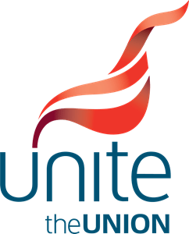 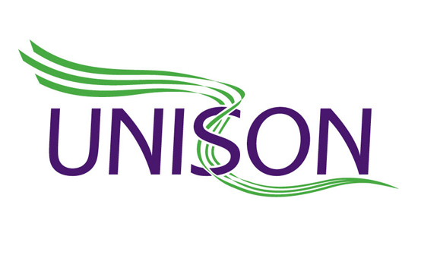 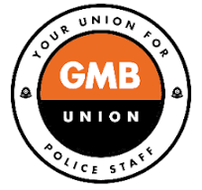

**POLICE STAFF COUNCIL TRADE UNION SIDE BULLETIN 3/2024**

**5 AUGUST 2024**

**POLICE STAFF PAY TALKS TO START ON 29 AUGUST**

Following the announcement on 23 July that police officers are to receive a 4.75% pay rise this year, the Employers Side of the Police Staff Council are now consulting chief constables and police and crime commissioners on what to offer police staff. For both officers and staff, pay rises take effect from 1 September each year.

Although the police officer and police staff pay awards are not formally linked, members will be aware that, since 2000, police staff have never been awarded a lower pay rise than their police officer colleagues. This has happened for reasons of fairness, equality and parity of esteem.

The Employers Side confirmed last week that its consultation with chief constables and police and crime commissioners will be concluded in time for formal talks on the police staff pay offer to open on 29 August.

Although this is earlier than previously anticipated, it does not mean that the eventual police staff pay award will be paid in September. Negotiations may go on into September and then each trade union will consult its police staff members on the final offer, which will take a number of weeks. So, the earliest likely implementation date, if members vote to accept the eventual offer, is going to be in October 2024.

If you have any questions on the pay talks please contact your local union branch in the first instance.